Jewelry Drive

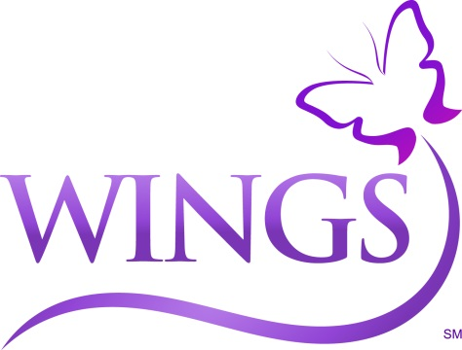

**When:** [insert info.]

**Where:** [insert info.]

**What:** A jewelry drive benefiting WINGS Program, Inc. WINGS is a non-profit providing housing, integrated services, education and advocacy to end domestic violence.

**R.S.V.P.:** [insert date]